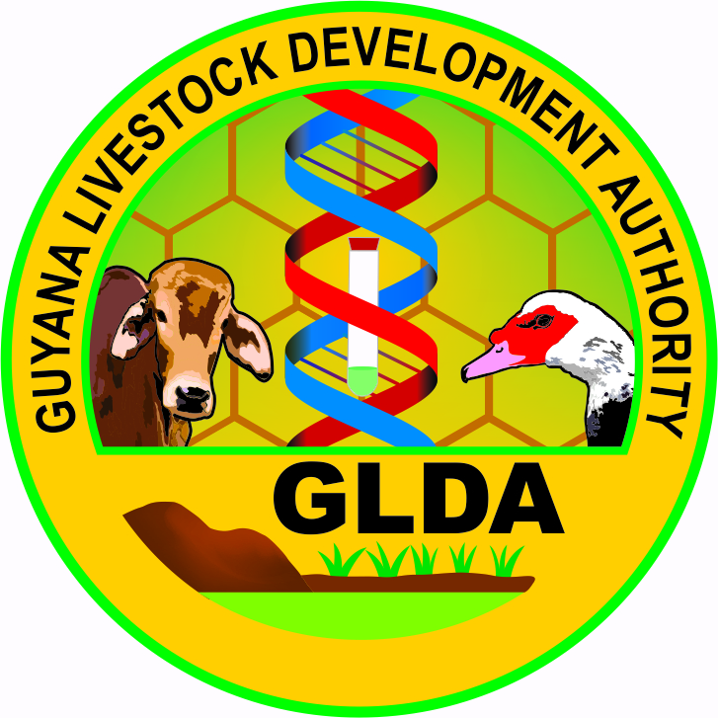

***MINISTRY OF AGRICULTURE***

***GUYANA LIVESTOCK DEVELOPMENT AUTHORITY***

***ANIMAL HEALTH UNIT***

***Tract GLDA***

***Mon Repos Email: glda1910@gmail.com***

***East Coast Demerara, Fax: 220-6557 Guyana***

***EXPORT HEALTH CERTIFICATE APPLICATION (LIVE ANIMALS)***

*Date of Application: - ……………….....*

*Consignor: - ……………………………………………..……………….*

*Address: - ...………………………………………………………….....*

*Consignee: - ………………………………………………………………*

*Address ……………………………………………………………….*

*Telephone / Fax #: - …..…………………………………………………………..*

*Number of Animal(s)/Birds: - ……………………………………………………………..*

*Species: - ………………………………………………………………*

*Breed of Animal(s) /Birds: - ………………………………………………………………*

*Sex of Animal(s)/Birds: - ………. Age of Animal(s)/Bird ……….. Weight ……..…….*

*Colour and Markings: - ……………………………………………………………….*

*Microchip #: ………………………… Hair Coat ……………..……..……..*

*Animal Name: …………………………….*

*Expected Date of Departure: - …………………………………..…………..………………*

*Countries visited over last six (6) months: - ………………………………………………*

*Vaccination Status: - (i) RABIES: Yes …… No …… (ii) OTHER ………………………*

*Date of inspection of Animal: - ……………………………………………………………...*

*Permit collection date: - ………………………………………………………………*

***For additional information please contact Telephone numbers: 220-6557, 220 - 6556, and 220 – 2864***