Call for Recipes for the Ministry of Agriculture Cookbook

Help us get healthy, enjoy cooking, and eat locally produced food!

Do you have a favorite recipe or an ingenious way of preparing ‘home grown’ food?

Send it in!
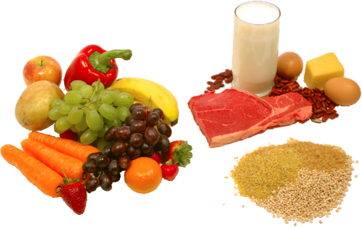
The Ministry of Agriculture invites submissions of recipes, tips and ideas for our annual “Cookbook.” Let’s improve our nutrition and enjoy meals with locally produced food!

Guidelines for submissions:
- Recipe submissions:
- All ingredients should be locally grown or produced; utilize local substitutes for foreign ingredients where possible.
- All ingredients should be listed in order of use. Indicate if they are chopped, minced, melted, etc.
- Contributors should be sure to include accurate package sizes and to provide the pan sizes needed for each recipe. Measurements should be as precise as possible.
- Baking times should be accurate and give a test for completion. (e.g. Bake for 45 to 50 minutes, until golden brown. Cool completely, then cover and refrigerate overnight.)
- Indicate whether to cook a recipe covered or not.
- Indicate if you can make it ahead of time and if it can be frozen and/or reheated before serving.
- Indicate the number of servings.
- Make sure there are no "dangling" ingredients - i.e., instructions that tell you to prepare an ingredient and set it aside (e.g., drain juice, reserving 1/2 cup), then the reserved ingredient isn't added to the recipe!

Photo
Submit at least two photos (no less than 300 dpi) for publication with your recipe

Style:
In order to ensure the most accurate reproduction of your recipe, the following format should be used when submitting the recipe details.

NAME OF DISH
INGREDIENTS:
1. 1 cup of ingredient A
2. 2 tablespoons of ingredient B
3. 1 kg of ingredient C

PROCEDURE:
1. Pour 2 tablespoons of oil into a frying pan to heat. Add ingredient A and sauté until golden brown.
2. Add ingredient B ….

Recommended Serving Size: (state serving size)
Makes: (state number) servings

- How to submit:
  - Include your name and contact information
  - Email: agri.pr.gy@gmail.com
  - Mail to: Coordinator, Communication Unit, Ministry of Agriculture, Regent and Shiv Chanderpaul Drive, Bourda, Georgetown
  - Deadline for submissions: August 19th, 2016.

Credit will be given for each recipe used in the publication.

Thank you for helping us all get healthy!
The proceeding of the Cookbook will go to a charity.

